Hazardous Gas Detection System

Name: Ankit Kumar (21781A04M0)

Ranvir Kumar (21781A04M8)

Manish Kumar ray (21781A04M2)

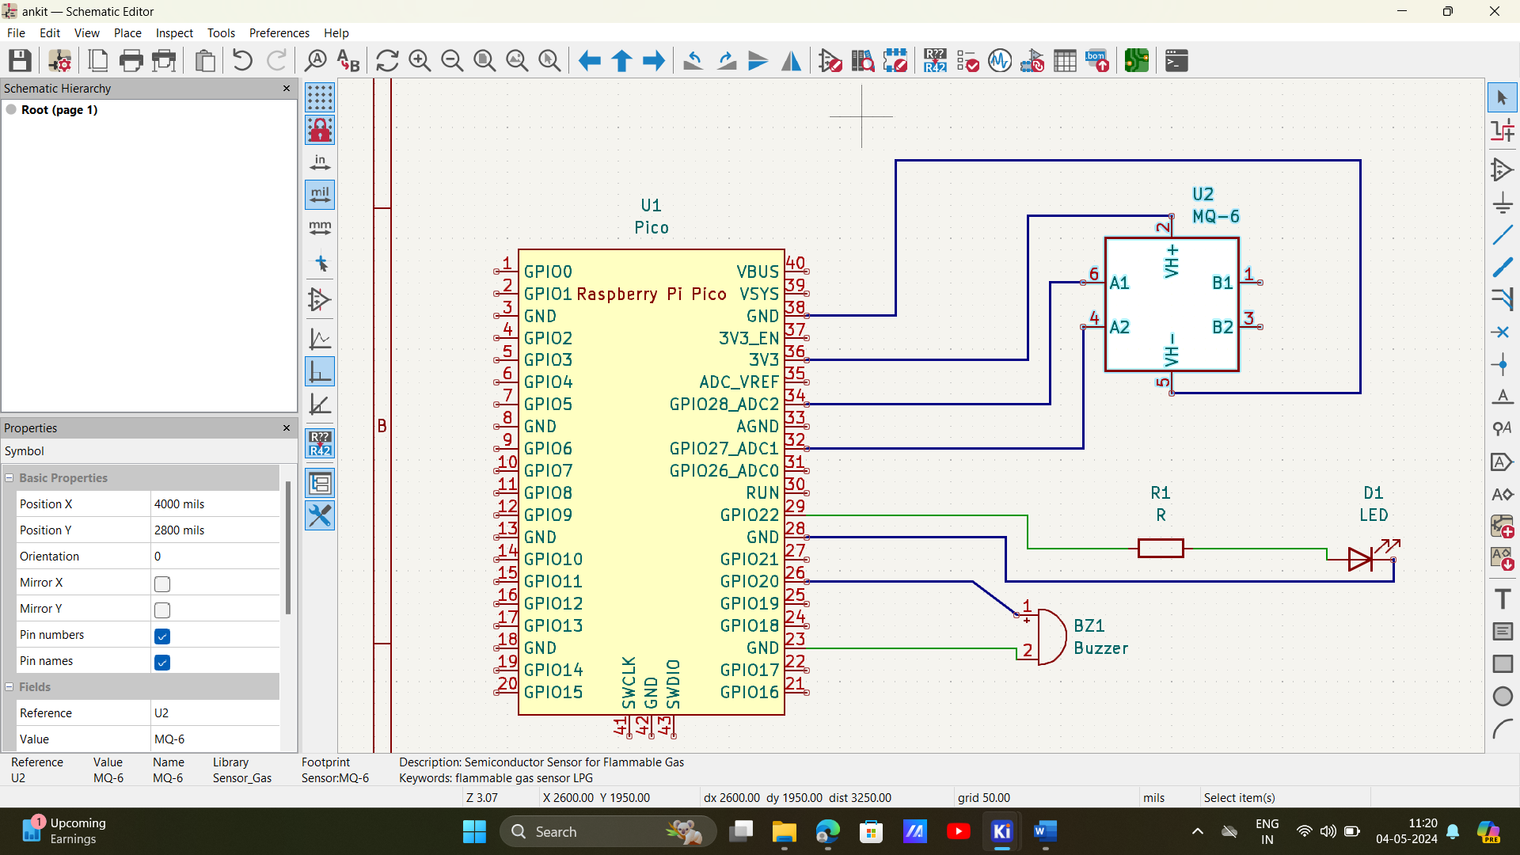

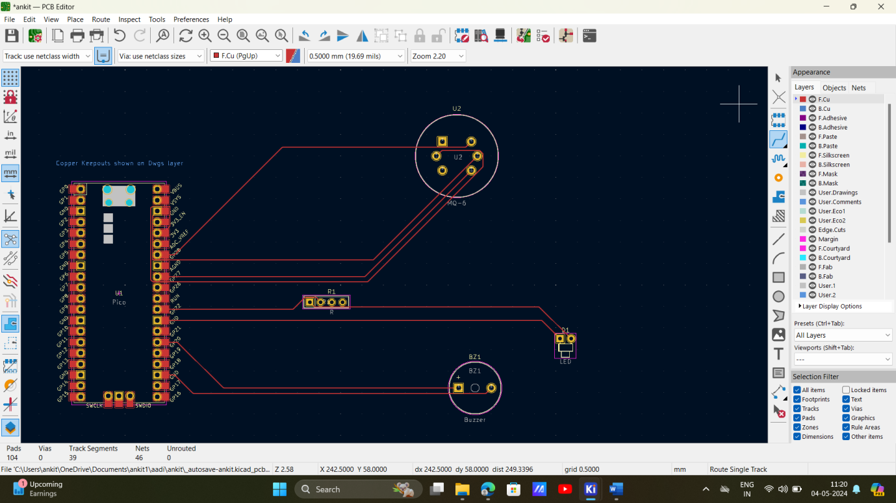

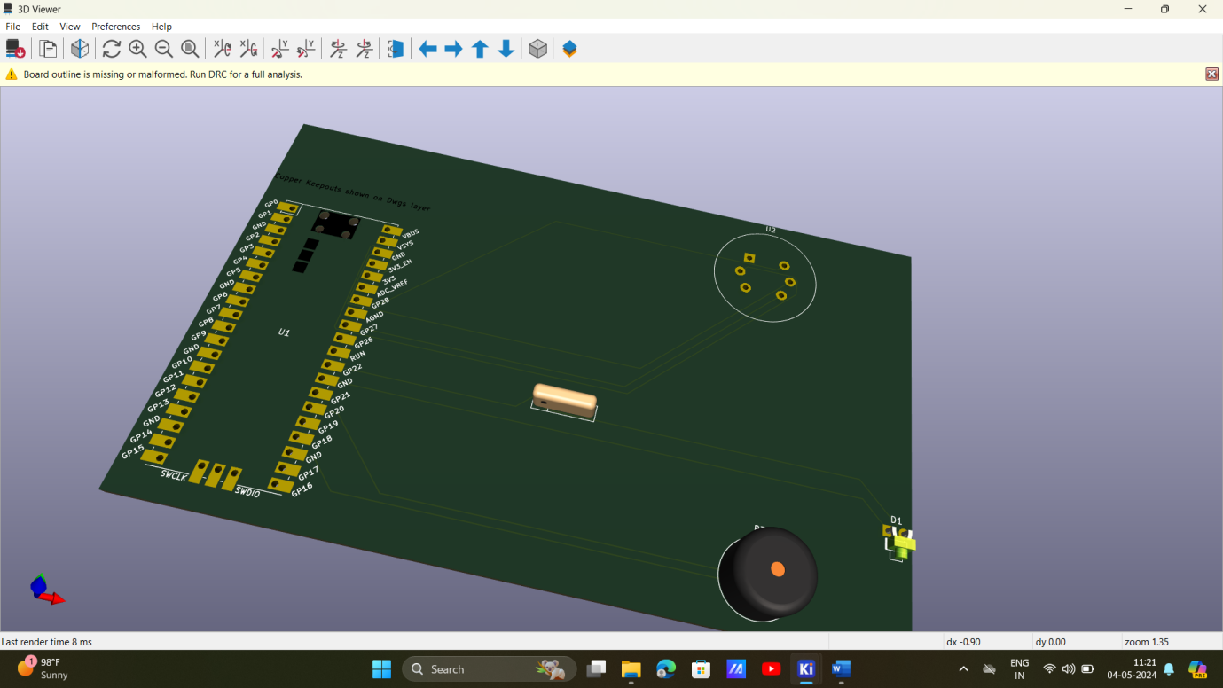

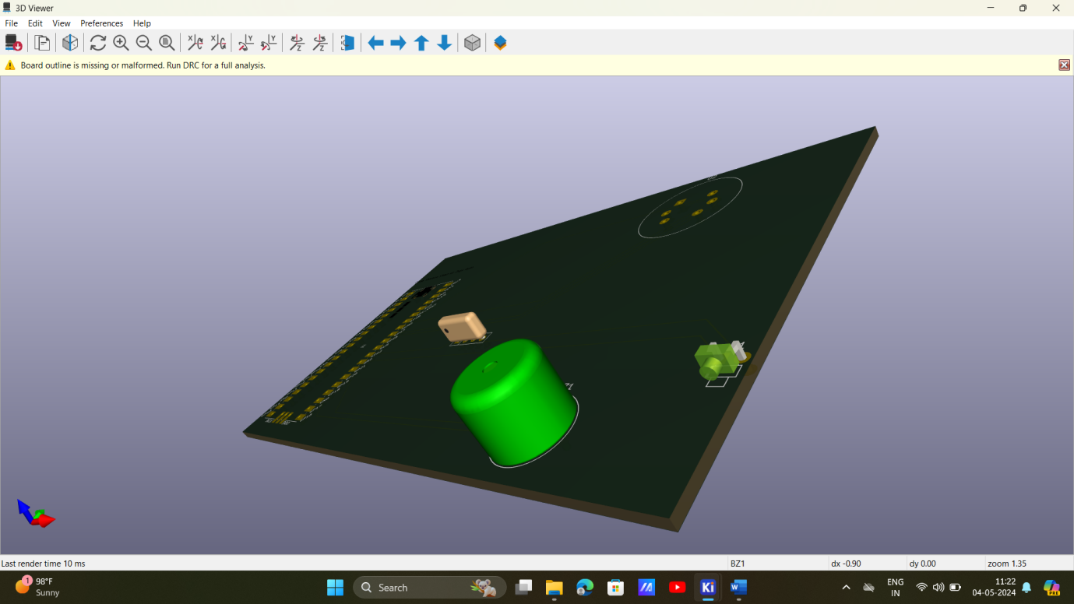

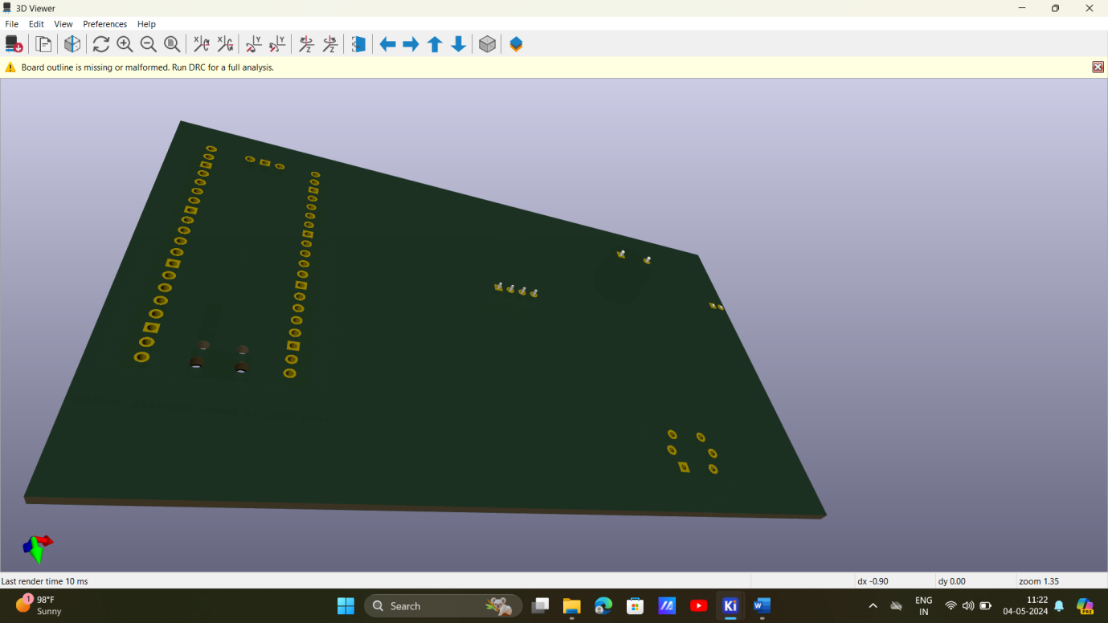

PROGRAM

import machine

import time

# Define pin numbers

PIR_PIN= machine. Pin(27, machine. Pin.IN)

BUZZER_PIN =machine. Pin(6, machine. Pin. OUT)

# Function to activate the buzzer

def activate_buzzer():

BUZZER_PIN.on() #Turn buzzer on

time.sleep(0.5) #Keep buzzer on for 6.5 seconds.

BUZZER_PIN.off() #Turn buzzer off

# Main loop to detect motion

while True:

if PIR_PIN.value(): #PIR sensor detects motion

print("Motion detected!")

activate_buzzer() # Activate the buzzer

time.sleep(0.2) #Small delay to debounce and save CPU

output:

Motion detected

Motion detected

Motion detected

Motion detected

Motion detected

Motion detected

Motion detected

Motion detected



Conclusion:

In conclusion, the development and implementation of a Hazardous Gas Detection System represent a crucial step towards ensuring safety in various environments, from industrial settings to residential areas. By continuously monitoring air quality and promptly detecting the presence of hazardous gases, this system not only protects human lives but also safeguards the environment and valuable assets. Through advanced sensor technologies, data analytics, and real-time alerts, it offers proactive measures to mitigate risks and prevent potential disasters. Moving forward, ongoing research and innovation in this field will further enhance the efficacy and accessibility of such systems, ultimately contributing to a safer and healthier world for all.

